**A PROJECT REPORT**

**ON**

**CREATE A SINGLE-PAGE PORTFOLIO WEBSITE**

**IN THE DOMAIN OF**

**FRONT-END WEB DEVELOPMENT**

**BY**

**MALLAVARAPU LAKSHMI PRAHARSHA**

**DATE:29-02-2023**

**TABLE OF CONTENTS**

**S. No Topic Page no.**

1. Abstract 3

2. Objectives 4-7

3. Introduction 8

4. Methodology 9-11

5. Code 12-30

6. Results and Outputs 31-35

7. Conclusion 36

**ABSTRACT**

In today's digital age, establishing an online presence is paramount for professionals and creatives alike. A single-page portfolio website serves as a powerful tool to showcase one's skills, projects, and accomplishments in a concise and visually appealing manner. This abstract presents a comprehensive guide to creating such a website using HTML, CSS, JavaScript, and Bootstrap 5. The foundation of the website will be built with HTML, providing the structure and content markup. Through semantic HTML elements, we ensure accessibility and search engine optimization (SEO) while organizing the content efficiently. CSS will then be utilized to enhance the aesthetics and layout of the website. Leveraging CSS frameworks like Bootstrap 5 accelerates the development process by offering pre-designed components and responsive design capabilities. JavaScript will be incorporated to add interactivity and dynamic functionality to the website. This includes features such as smooth scrolling, interactive navigation, and modal dialogs for showcasing projects. By harnessing JavaScript's capabilities, we create a seamless user experience that engages visitors and highlights the portfolio's content. Throughout the development process, attention will be paid to responsive design principles, ensuring that the website functions flawlessly across various devices and screen sizes. Media queries and Bootstrap's grid system will be utilized to achieve this responsiveness, providing an optimal viewing experience for users on desktops, tablets, and smartphones. In conclusion, this abstract outlines the methodology for creating a single-page portfolio website using HTML, CSS, JavaScript, and Bootstrap 5. By following these guidelines, individuals can effectively showcase their skills and projects to potential clients and employers, establishing a strong online presence in today's competitive landscape.

**OBJECTIVE**

The following objectives are taken into account while creating a single-page portfolio website:

1. Showcase Professional Identity.
2. Highlight Portfolio Projects.
3. Ensure User Experience.
4. Implement Responsive Design.
5. Enhance Visual Appeal.
6. Integrate Interactive Elements.
7. Optimize Performance.
8. Ensure Accessibility and SEO.

**Showcase Professional Identity:**

The primary aim of this project is to develop a visually striking and professional website that serves as an effective platform for communicating the creator's identity, skills, and expertise to a diverse audience, including potential clients, employers, and collaborators. By leveraging modern design principles and aesthetic considerations, the website seeks to captivate visitors from the moment they land on the page, leaving a lasting impression of professionalism and credibility. Through carefully curated content and strategically placed elements, such as an engaging bio, portfolio showcases, and skill highlights, the website endeavors to provide a comprehensive overview of the creator's capabilities and achievements. Moreover, by incorporating user-friendly navigation and intuitive layout design, the website ensures ease of exploration, allowing visitors to seamlessly delve into different sections and uncover the depth of the creator's expertise. Ultimately, the overarching goal is to establish a compelling online presence that not only showcases the creator's talents but also fosters trust and confidence among potential clients and collaborators, paving the way for meaningful professional connections and opportunities.

**Highlight Portfolio Projects:**

The envisioned platform is meticulously crafted to serve as an immersive showcase for the creator's past projects, works, and notable achievements. Through thoughtful design and strategic organization, visitors are invited into a dynamic journey of exploration and discovery. Each project is meticulously presented within a structured framework, allowing for a comprehensive understanding of the creator's diverse skill set and accomplishments. Utilizing captivating visuals, compelling narratives, and interactive elements, the platform seamlessly guides visitors through a curated selection of works, offering insights into the creator's creative process, problem-solving abilities, and unique perspective. By fostering an engaging and informative environment, the platform not only highlights the depth and breadth of the creator's portfolio but also fosters a deeper connection with visitors, igniting curiosity and inspiring further exploration. Ultimately, the platform serves as a powerful testament to the creator's talent and expertise, positioning them as a standout professional within their respective field and leaving a lasting impression on visitors.

**Ensure User Experience:**

Central to the project's vision is the prioritization of user experience through the creation of an intuitive and seamlessly navigable interface. Every design decision is guided by the overarching goal of ensuring effortless interaction with the portfolio content, regardless of the device or screen size being utilized. Through a combination of user-centric design principles and responsive layout techniques, the interface is meticulously crafted to adapt dynamically to various viewing contexts, providing an optimal experience for every visitor. Emphasis is placed on intuitive navigation pathways, clear call-to-action elements, and streamlined interactions, fostering a sense of familiarity and ease of use that empowers users to explore the portfolio content with confidence and efficiency. By placing the user at the forefront of the design process, the interface not only enhances accessibility and usability but also cultivates a positive and memorable interaction that resonates with visitors long after their initial engagement with the platform.

**Implement Responsive Design:**

The project employs a robust responsive design strategy to guarantee a seamless and visually appealing experience across various viewport sizes, encompassing desktops, tablets, and smartphones. Through the meticulous application of responsive design techniques, the website effortlessly adapts to different screen dimensions, ensuring that content remains accessible, legible, and aesthetically pleasing regardless of the device being used. Leveraging fluid grids, flexible images, and media queries, the website dynamically adjusts its layout and presentation, optimizing the user experience and preserving content integrity across diverse viewing contexts. By prioritizing versatility and accessibility, the website not only accommodates the evolving landscape of digital devices but also underscores a commitment to inclusivity, enabling all users to engage with the content comfortably and enjoy a truly immersive browsing experience. Furthermore, the website's responsive design is augmented by robust testing methodologies, encompassing a wide range of devices, browsers, and operating systems. Through device-agnostic testing frameworks and browser compatibility checks, the website undergoes rigorous scrutiny to ensure consistent functionality and visual fidelity across diverse environments. This meticulous testing regimen serves to validate the efficacy of responsive design implementations while identifying and remedying potential compatibility issues proactively.

**Enhance Visual Appeal:**

CSS styling serves as a powerful tool in elevating the visual appeal of the portfolio website, infusing it with contemporary design sensibilities that resonate with visitors. Drawing inspiration from modern design trends, the project meticulously applies CSS techniques to craft a visually captivating aesthetic that leaves a lasting impression. Thoughtfully curated typography choices imbue the website with personality and readability, while carefully selected color schemes evoke mood and reinforce brand identity. Furthermore, innovative layout techniques are employed to create visual interest and guide user focus, ensuring that visitors are seamlessly drawn into the portfolio's narrative. By harmonizing these elements, the website not only captivates and engages visitors but also establishes a distinct visual identity that sets it apart in a competitive digital landscape.

**Integrate Interactive Elements:**

JavaScript serves as a cornerstone in enriching the user experience of the single-page portfolio website by introducing a host of interactive elements and functionalities. Smooth scrolling, facilitated through JavaScript libraries or custom scripts, enhances navigation fluidity, ensuring seamless transitions between different sections of the website. Animated transitions further elevate the visual appeal, captivating users as they navigate through the content. Interactive navigation menus empower users with intuitive browsing options, enabling them to explore portfolio items effortlessly. Additionally, modal dialogs offer a sophisticated means of showcasing portfolio projects, providing users with immersive, focused experiences when interacting with individual items. Through the strategic incorporation of JavaScript, the website transcends static limitations, fostering engagement and interactivity while showcasing the creator's portfolio dynamically and compellingly.

**Optimize Performance:**

Efficient performance optimization lies at the core of the single-page portfolio website's development strategy, aiming to deliver a swift and responsive browsing experience to users. By prioritizing load time minimization, the website ensures that visitors can access content quickly, reducing bounce rates and enhancing user engagement. This optimization extends to image sizes, where careful compression and optimization techniques are employed to strike a balance between visual quality and file size, resulting in expedited loading times without compromising visual fidelity. Moreover, adherence to best practices for code organization and asset management ensures streamlined workflows and minimal overhead, facilitating efficient development iterations and maintenance cycles. Through a concerted effort to optimize performance across all fronts, the website stands poised to deliver a fast, seamless, and enjoyable browsing experience for users, thereby enhancing user satisfaction and retention.

**Ensure Accessibility and SEO:**

A foundational aspect of the single-page portfolio website's development revolves around implementing semantic HTML markup and integrating accessibility features to foster inclusivity and compliance with web accessibility standards. By adhering to semantic HTML practices, the website prioritizes structural clarity and content hierarchy, enhancing screen reader compatibility and facilitating navigation for users with disabilities. Furthermore, the inclusion of accessibility features, such as alt attributes for images, aria labels for interactive elements, and keyboard navigation support, ensures an equitable browsing experience for all users, regardless of their abilities.

In tandem with accessibility considerations, the website also embraces SEO (Search Engine Optimization) best practices to enhance its visibility and search engine rankings. Through strategic keyword research, meta-tag optimization, and content structuring, the website aims to maximize its discoverability and relevance within search engine results pages (SERPs). Additionally, the integration of descriptive and keyword-rich content, alongside proper URL structuring and sitemap generation, further augments the website's SEO performance, enabling it to attract organic traffic and reach a wider audience effectively.

By combining efforts to prioritize accessibility and SEO optimization, the single-page portfolio website not only upholds ethical standards of inclusivity but also positions itself for improved visibility and discoverability across the digital landscape. Through these concerted efforts, the website endeavors to provide a seamless and equitable browsing experience while maximizing its reach and impact within relevant online communities and search engine ecosystems.

**INTRODUCTION**

In today's digital era, establishing a strong online presence is paramount for professionals and creatives seeking to showcase their skills, projects, and accomplishments to a global audience. A single-page portfolio website stands as an indispensable tool in this endeavor, offering a streamlined and visually captivating platform to encapsulate one's identity, expertise, and portfolio succinctly and engagingly. Tasked with the creation of such a website using HTML, CSS, JavaScript, and Bootstrap 5, the project presents an exciting opportunity to amalgamate cutting-edge web technologies with innovative design principles to craft a dynamic and immersive user experience.

As the cornerstone of modern web development, HTML (Hypertext Markup Language) provides the structural framework upon which the portfolio website will be built. Through the strategic utilization of semantic HTML elements, the website's content will be organized and marked up in a manner that not only enhances accessibility and search engine optimization (SEO) but also facilitates efficient navigation and content comprehension for users. With HTML serving as the foundation, the subsequent layers of design and interactivity will be overlaid to create a cohesive and compelling user experience.

CSS (Cascading Style Sheets) emerges as the next vital component in the creation of the single-page portfolio website, offering unparalleled flexibility in defining the website's visual aesthetics and layout. Leveraging CSS, the website's design will be imbued with stylistic flourishes, captivating typography, and responsive layout elements that adapt seamlessly to various viewport sizes and devices. Through the judicious application of CSS frameworks like Bootstrap 5, the development process is streamlined, enabling rapid iteration and ensuring consistency in design across different sections of the website.

JavaScript injects interactivity and dynamism into the portfolio website, elevating it beyond static content to foster engagement and user interaction. With JavaScript, dynamic elements such as smooth scrolling effects, animated transitions, and interactive navigation menus will be implemented to enhance user experience and immersion. Additionally, JavaScript facilitates the creation of modal dialogs and interactive galleries for showcasing portfolio items, enabling users to interact with and explore the creator's work in a captivating and intuitive manner.

Bootstrap 5, the latest iteration of the popular front-end framework, emerges as a linchpin in the development process, offering a robust toolkit of pre-designed components, utilities, and responsive grid systems. By harnessing the power of Bootstrap 5, the project benefits from accelerated development workflows, enhanced responsiveness, and improved cross-browser compatibility, while ensuring adherence to contemporary design standards and best practices.

In conclusion, the task of creating a single-page portfolio website using HTML, CSS, JavaScript, and Bootstrap 5 represents a multifaceted endeavor that combines technical proficiency with creative ingenuity. Through the seamless integration of these technologies, the project endeavors to deliver a visually stunning, interactive, and user-centric platform that not only showcases the creator's talents and achievements but also captivates and inspires visitors, leaving a lasting impression in the competitive digital landscape.

**METHODOLOGY**

The "methodology" in the domain of web development refers to a systematic approach or framework used to plan, design, build, deploy, and maintain web applications or websites. It encompasses the processes, practices, and techniques employed by developers and teams to ensure the successful completion of web development projects. Methodologies in web development help streamline the development process, improve efficiency, maintain consistency, and ultimately deliver high-quality products.

**Planning and Designing:**

Initially, define the purpose of your portfolio website identify your target audience, and plan the layout and structure of your website, including the sections you want to include (e.g., About Me, Skills, Projects, Experience, Contact). Now sketch a rough wireframe or mock-up to visualize the design.

The project code includes a static website written in HTML, CSS, and JavaScript, specifically using Bootstrap 5 for styling and layout. The website appears to be a personal portfolio and has various sections, including a navigation bar, Carousel, About section, Skills section, Experience section, Projects section, Contact section, and Footer section.

**Setting Up Your Project:**

Create a new directory for your project on your local machine. Once you've created a new directory for your project on your local machine, you can proceed with setting up your HTML and CSS files.

First, open your preferred code editor and create two new files within your project directory: index.html and styles.css. The index.html file will serve as the main HTML document for your website, while styles.css will contain the CSS styles for styling your webpage.

In your index.html file, start by setting up the basic structure of an HTML document. The link element is used to link your styles.css file to your HTML document, allowing you to apply custom styles to your webpage.

Bootstrap 5 CSS file is linked via a CDN (Content Delivery Network). Make sure to replace "https://cdn.jsdelivr.net/npm/bootstrap@5.3.0-alpha1/dist/css/bootstrap.min.css" with the appropriate Bootstrap 5 version and integrity hash.

At the end of the body tag, the script tag is used to link Bootstrap 5 JavaScript files. This enables Bootstrap functionalities such as dropdowns, modals, and more.

With these setup steps completed, we are ready to start building and styling your single-page portfolio website using HTML, CSS, and Bootstrap 5.

**Building the Structure with HTML:**

The basic structure includes a header with a navigation bar, a main content area with sections for home, about, portfolio, skills, experience, projects, and contact, and a footer with copyright information and social media links. Placeholders for content are included within each section, allowing you to add more specific content as needed.

The <header> contains the heading of the website.

The <nav> element includes navigation links to different sections of the webpage.

The <main> section contains the main content of the webpage, divided into sections (<section>) for About Me, Portfolio, and Contact Me.

Each section has a unique id attribute, allowing navigation links to jump to specific sections.

The <footer> contains copyright information and additional footer content.

**Styling with CSS:**

Apply styles to your HTML elements to achieve the desired layout and appearance. Utilize Bootstrap 5 classes for styling and responsiveness. To apply styles to the HTML elements and utilize Bootstrap 5 classes for styling and responsiveness, you can create custom CSS rules in your styles.css file. Custom styles are applied to elements such as the body, header, nav, main, section, and footer to achieve the desired layout and appearance. Bootstrap 5 classes are utilized in the HTML markup (e.g., navbar, nav-link) for styling and responsiveness. Custom color, fonts, padding, and margins are defined to match the design mock-up. You can adjust these styles according to your specific design requirements and preferences. Additionally, you can use Bootstrap's extensive library of utility classes to further customize the appearance and layout of your website.

**Creating the Portfolio Content:**

Populate your portfolio section with projects or works you want to showcase. Use images, text, and possibly links to provide details about each project. Ensure that the content is well-organized and visually appealing. Each project is represented by a <div class="col-md-4"> within the Bootstrap grid system, which ensures proper layout and responsiveness.

Inside each project <div>, a Bootstrap card component is used to display project information, including an image (<img>), project title (<h5 class="card-title">), project description (<p class="card-text">), and a button (<a href="#" class="btn btn-primary">) to learn more. Customize the project descriptions and titles to provide relevant details about each project. Ensure that the content is visually appealing by using high-quality images, clear and concise descriptions, and consistent styling throughout the portfolio section.

**Adding Navigation:**

Implement smooth scrolling navigation between sections using JavaScript or Bootstrap's built-in functionality. Include a navigation menu that allows users to easily navigate to different sections of the page.

Smooth scrolling navigation enhances user experience by seamlessly transitioning between sections of a webpage. Implementing this feature ensures a fluid and intuitive browsing experience for visitors, especially on single-page websites. By incorporating a navigation menu with links to different sections, users can easily navigate to specific content areas without manual scrolling. Whether through JavaScript or Bootstrap's built-in functionality, smooth scrolling adds a touch of elegance and professionalism to the website, improving overall usability and engagement. It's a subtle yet impactful enhancement that contributes to a positive user journey and leaves a lasting impression on visitors.

**Making it Responsive:**

By testing the website on various devices and screen sizes to ensure responsiveness. Use Bootstrap 5's grid system and responsive utilities to make your website adapt to different viewport sizes.

Bootstrap's grid system is based on a 12-column layout, which allows you to create flexible and responsive designs. By using classes such as col, col-sm, col-md, col-lg, and col-xl, you can define how many columns each element should occupy at different screen sizes.

Bootstrap offers responsive utility classes that allow you to show or hide elements based on screen size (d-*-none, d-*-block, d-*-inline, etc.), control visibility (visible-* and invisible-*), and adjust spacing (m-* and p-*).

By using Bootstrap's grid system and responsive utilities effectively, you can ensure that your website adapts seamlessly to various devices and screen sizes, providing an optimal viewing experience for all users.

**File Structure:**

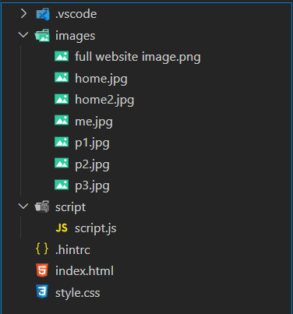

**CODE**

**index.html**

<!DOCTYPE html>

<html lang="en">

<head>

    <meta charset="UTF-8">

    <meta  name="viewport" content="width=device-width, initial-scale=1.0"/>

    <meta  http-equiv="X-UA-Compatible" content="ie=edge">

    <meta name="description" content="creation of single page portfolio website">

    <meta name="keywords" content="portfolio, single page portfolio, one page portfolio, web developer, web designer">

    <meta name="author" content="Praharsha">

    <title>Single Portfolio page</title>

    <link href="https://fonts.googleapis.com/css2?family=Moon+Dance&display=swap" rel="stylesheet">

    <link href="https://cdn.jsdelivr.net/npm/bootstrap@5.1.3/dist/css/bootstrap.min.css" rel="stylesheet">

    <link rel="stylesheet" href="https://maxcdn.bootstrapcdn.com/font-awesome/4.7.0/css/font-awesome.min.css">

    <script src="https://cdn.jsdelivr.net/npm/@popperjs/core@2.11.8/dist/umd/popper.min.js" integrity="sha384-I7E8VVD/ismYTF4hNIPjVp/Zjvgyol6VFvRkX/vR+Vc4jQkC+hVqc2pM8ODewa9r" crossorigin="anonymous"></script>

    <script src="https://cdn.jsdelivr.net/npm/bootstrap@5.3.3/dist/js/bootstrap.min.js" integrity="sha384-0pUGZvbkm6XF6gxjEnlmuGrJXVbNuzT9qBBavbLwCsOGabYfZo0T0to5eqruptLy" crossorigin="anonymous"></script>

    <link href="style.css" rel="stylesheet">

    <a href="https://www.freepik.com/free-photo/beautiful-woman-holding-clipboard_11938229.htm#fromView=search&page=1&position=20&uuid=339db981-905d-475c-8808-770781da1ca7"></a>

    <a href="https://www.freepik.com/free-photo/top-view-person-writing-laptop-with-copy-space_10570571.htm#fromView=search&page=1&position=14&uuid=39cffb0b-1b24-49d4-93d2-365b48792000"></a>

    <a href="https://www.freepik.com/free-photo/close-up-male-hands-using-laptop-home_1025837.htm#fromView=search&page=1&position=22&uuid=ae04fa07-1c53-49c2-90d1-e1bddcb60c86"></a>

</head>

<body>

    <!--NAVIGATION BAR STARTS-->

    <nav class="navbar navbar-expand-lg navbar-light fixed-top">

        <div class="container">

            <a class="navbar-brand" href="#"><span class="text-warning">My</span> Portfolio</a> <button aria-controls="navbarSupportedContent" aria-expanded="false" aria-label="Toggle navigation" class="navbar-toggler" data-bs-target="#navbarSupportedContent" data-bs-toggle="collapse" type="button"><span class="navbar-toggler-icon"></span></button>

            <div class="collapse navbar-collapse" id="navbarSupportedContent">

                <ul class="navbar-nav ms-auto mb-2 mb-lg-0">

                    <li class="nav-item">

                        <a class="nav-link" href="#">Home</a>

                    </li>

                    <li class="nav-item">

                        <a class="nav-link" href="#about">About</a>

                    </li>

                    <li class="nav-item">

                        <a class="nav-link" href="#skills">Skills</a>

                    </li>

                    <li class="nav-item">

                        <a class="nav-link" href="#experience">Experience</a>

                    </li>

                    <li class="nav-item">

                        <a class="nav-link" href="#projects">Projects</a>

                    </li>

                    <li class="nav-item">

                        <a class="nav-link" href="#contact">Contact</a>

                    </li>

                </ul>

            </div>

        </div>

    </nav>

    <!--NAVIGATION BAR ENDS-->

    <!--PORTFOLIO SINGLE PAGE CONTENT STARTS HERE-->

    <!--CAROUSEL STARTS-->

    <div id="carouselExampleCaptions" class="carousel slide" data-bs-ride="carousel">

            <div class="carousel-indicators">

            <button type="button" data-bs-target="#carouselExampleCaptions" data-bs-slide-to="0" class="active" aria-current="true" aria-label="Slide 1"></button>

            <button type="button" data-bs-target="#carouselExampleCaptions" data-bs-slide-to="1" aria-label="Slide 2"></button>

            </div>

            <div class="carousel-inner">

            <div class="carousel-item active">

                <img src="images/home2.jpg" class="d-block w-100" alt="profile">

                <div class="carousel-caption d-none d-md-block">

                <h5 style="color: black;">Hello There! </h5>

                <h4 style="color: black;">I am <strong>Anna</strong></h4>

                </div>

            </div>

            <div class="carousel-item">

                <img src="images/home.jpg" class="d-block w-100" alt="laptop">

                <div class="carousel-caption d-none d-md-block">

                <h5 style="color: black;">I am a FrontEnd Developer</h5>

                </div>

            </div>

            </div>

            <button class="carousel-control-prev" type="button" data-bs-target="#carouselExampleCaptions" data-bs-slide="prev">

            <span class="carousel-control-prev-icon" aria-hidden="true"></span>

            <span class="visually-hidden">Previous</span>

            </button>

            <button class="carousel-control-next" type="button" data-bs-target="#carouselExampleCaptions" data-bs-slide="next">

            <span class="carousel-control-next-icon" aria-hidden="true"></span>

            <span class="visually-hidden">Next</span>

            </button>

    </div>

    <!--CAROUSEL ENDS-->

    <!------ABOUT SECTION STARTS------>

    <section  id="about" class="container mt-3">

        <div class="container my-5" id="about">

            <div class="row">

            <div class="col-lg-6">

                <img class="w-100 shadow" src="images/me.jpg" />

            </div>

            <div class="col-lg-6">

                <div class="p-5 mt-4">

                    <h1 class="display-4">About Me</h1>

                    <h4><b>I am available for UI UX Design Project.</b></h4>

                    <p>Hi, I am Anna Devin, From USA. Graduate from Chicago University. Completed my Masters in Computer Science and Engineering with Specialization in UI UX Designing. </p>

                    <a href="#" class="btn btn-outline-dark">Download CV</a>

                </div>

            </div>

        </div>

    </section>

    <!--ABOUT SECTION ENDS-->

<!------SKILL SECTION STARTS------>

    <section  class="bg-light text-center py-5">

        <div class="container" id="skills">

                <h2 class="heading-text">My Skills</h2>

                <div class="skills-container">

                    <div>

                        <div class="skill">

                            <b>HTML</b>

                            <span>95%</span>

                            <div>

                                <span style="width:95%"></span>

                            </div>

                        </div>

                        <div class="skill">

                            <b>CSS</b>

                            <span>91%</span>

                            <div>

                                <span style="width:91%"></span>

                            </div>

                        </div>

                        <div class="skill">

                            <b>JavaScript</b>

                            <span>85%</span>

                            <div>

                                <span style="width:85%"></span>

                            </div>

                        </div>

                        <div class="skill">

                            <b>React js</b>

                            <span>79%</span>

                            <div>

                                <span style="width:79%"></span>

                            </div>

                        </div>

                    </div>

                    <div>

                        <div class="skill">

                            <b>React</b>

                            <span>65%</span>

                            <div>

                                <span style="width:65%"></span>

                            </div>

                        </div>

                        <div class="skill">

                            <b>Jquery</b>

                            <span>85%</span>

                            <div>

                                <span style="width:85%"></span>

                            </div>

                        </div>

                        <div class="skill">

                            <b>Node</b>

                            <span>65%</span>

                            <div>

                                <span style="width:65%"></span>

                            </div>

                        </div>

                        <div class="skill">

                            <b>CMD</b>

                            <span>85%</span>

                            <div>

                                <span style="width:85%"></span>

                            </div>

                        </div>

                    </div>

                </div>

            </div>

        </div>

    </section><br>

<!--SKILLS SECTION ENDS-->

<!---EDUCATION AND EXPERIENCE SECTION STARTS--->

    <section id='experience' class="container secondary bg-lightgrey">

        <div class="container" id="experience">

        <div class="edu-exp">

            <h2 class="heading-text">Education</h2>

            <div class="experience-list">

                <div class="experience-content">

                    <h2>Harvard University </h2>

                    <h3>2005-2008</h3>

                    <p>Master in Computer Engineering</p>

                </div>

            </div>

            <div class="experience-list">

                <div class="experience-content">

                    <h2>Stanford University</h2>

                    <h3>2005-2008</h3>

                    <p>Doctor in Computer Engineering</p>

                </div>

                </div>

                <div class="experience-list">

                <div class="experience-content">

                    <h2>University of Oxford</h2>

                    <h3>2005-2008</h3>

                    <p>Bachelor in Computer Engineering</p>

                </div>

                </div>

                <div class="experience-list">

                <div class="experience-content">

                    <h2>University of Cambridge</h2>

                    <h3>2005-2008</h3>

                    <p>Polytechnic in Computer Engineering</p>

                </div>

                </div>

            </div>

            <div class="edu-exp">

                <h2 class="heading-text">Experience</h2>

                <div class="experience-list">

                <div class="experience-content">

                    <h2>Apple Inc Company</h2>

                    <h3>2023-current</h3>

                    <p>Font End Developer</p>

                </div>

                </div>

                <div class="experience-list">

                <div class="experience-content">

                    <h2>Google Inc Company</h2>

                    <h3>2021-2023</h3>

                    <p>Graphic design student portfolio websites template.</p>

                </div>

                </div>

                <div class="experience-list">

                <div class="experience-content">

                    <h2>Amazon Ecommerce Company</h2>

                    <h3>2019-2021</h3>

                    <p>Font End Developer</p>

                </div>

                </div>

                <div class="experience-list">

                <div class="experience-content">

                    <h2>Microsoft Adobe Company</h2>

                    <h3>2017-2019</h3>

                    <p>UI / UX Designer</p>

                </div>

                </div>

            </div>

                </div>

            </div>

    </section><br><br>

    <!--EDUCATION AND EXPERIENCE SECTION ENDS-->

    <!--PROJECT SECTION STARTS-->

<section id="projects" class="project-section bg-light">

    <div class="container" id="projects"><br>

        <h2 class="heading-text">My Projects</h2>

        <div class="row">

            <div class="col-md-4">

                <div class="card" style="width: 18rem;">

                    <img src="images/p1.jpg" class="card-img-top" alt="...">

                    <div class="card-body">

                        <h5 class="card-title">Web Development</h5>

                        <p class="card-text">The Dynamic Recipe Website project aimed to create a user-friendly platform for food enthusiasts to explore and share recipes. The website provides a dynamic interface where users can not only browse a vast collection of recipes but also contribute their own culinary creations. Through a modern and responsive design, users can seamlessly navigate the website on various devices, enhancing accessibility.</p>

                    </div>

                </div>

            </div>

            <div class="col-md-4">

                <div class="card" style="width: 18rem;">

                    <img src="images/p2.jpg" class="card-img-top" alt="...">

                    <div class="card-body">

                        <h5 class="card-title">Web Design</h5>

                        <p class="card-text">The primary objective of this project was to replicate the core features and aesthetics of Instagram's web interface while adding a touch of creativity and personalization. This involved meticulous attention to detail, from the layout and color scheme to the functionality of various components such as the feed, profile pages, and interactive elements.</p>

                    </div>

                </div>

            </div>

            <div class="col-md-4">

                <div class="card" style="width: 18rem;">

                    <img src="images/p3.jpg" class="card-img-top" alt="...">

                    <div class="card-body">

                        <h5 class="card-title">UI UX Design</h5>

                        <p class="card-text">The primary objective of this project was to build a user-friendly website.In the digital age, user experience (UX) and user interface (UI) design play pivotal roles in shaping the success of online platforms. As an enthusiast in enhancing digital interactions, I embarked on a transformative project aimed at revamping the UI/UX of Reddit, a leading social news aggregation, web content rating, and discussion website.</p>

                </div>

            </div>

        </div>

    </div>

</section><br><br>

<!--PROJECT SECTION ENDS-->

<!--CONTACT SECTION STARTS-->

    <div class="main-section contact bg-lightgrey"  id="contact">

    <div class="container" >

        <h2 class="heading-text">Get In Touch</h2>

        <div class="width-100">

            <form>

                <input type="text" placeholder="Full Name..." required>

                <input type="email" placeholder="Full Email Id..." required>

                <input type="phone" placeholder="Full Mobile No..." required>

                <textarea placeholder="Enter message..." required></textarea>

                <button type="submit" class="btn btn-primary">Submit</button>

            </form>

        </div>

            <div class="width-33">

            <h3>

                <i class="fa fa-map-marker"></i>

            </h3>

            <h4>Address</h4>

            <p>186, 3rd floor, near Hotel Galaxy Star, Near Sargam Cinema, Zone-II,M P Nagar</p>

        </div>

        <div class="width-33">

            <h3>

                <i class="fa fa-phone"></i>

            </h3>

            <h4>Phone</h4>

            <p>+91 1234567890</p>

        </div>

        <div class="width-33">

            <h3>

                <i class="fa fa-envelope-o"></i>

            </h3>

            <h4>Email</h4>

            <p>annadevin@yahoo.com</p>

        </div>

    </div>

    </div>

    <!--CONTACT SECTION ENDS-->

    <!------FOOTER SECTION STARTS------>

    <div class="footer">

        <center>

        <div class="container">

        <div class="footer-sect social-icon width-50">

            <a href="#">

            <i class="fa fa-facebook"></i>

            </a>

            <a href="#">

            <i class="fa fa-twitter"></i>

            </a>

            <a href="#">

            <i class="fa fa-linkedin"></i>

            </a>

        </div>

        <div class="footer-sect mt-20 width-50">CopyRight © 2023 annadevin.com Website Template. All Rights Reserved</div>

        </div>

        </center>

    </div>

    <!--FOOTER SECTION ENDS-->

    <script src="https://cdn.jsdelivr.net/npm/bootstrap@5.1.3/dist/js/bootstrap.bundle.min.js"></script>

</body>

</html>

The **index.html** file provided is a single-page portfolio website for example: (UI UX Designer named Anna Devin). The website includes a navigation bar, a carousel, an about section, a skills section, an education and experience section, a projects section, a contact section, and a footer. The navigation bar at the top of the page includes links to different sections of the website such as Home, About, Skills, Experience, Projects, and Contact. The carousel displays two images with captions that introduce Anna Devin. The About section includes an image of (e.g.: Anna Devin) and a short bio about her education and skills. It also includes a button to download her CV. The skills section displays Anna Devin's skills in various technologies such as HTML, CSS, JavaScript, React, Node, and more. Each skill is displayed as a progress bar indicating the level of expertise. The education and experience section displays (e.g. Anna Devin's) educational background and work experience. It includes the name of the institution, the degree obtained, and the duration of study or employment. The projects section displays three of (e.g. Anna Devin's) projects with images and brief descriptions. The contact section includes a form for visitors to fill out with their name, email, phone number, and message. It also includes (e.g. Anna Devin's) address, phone number, and email address. The footer includes social media icons and a copyright notice.

The website is built using HTML, CSS, and Bootstrap, and it includes external links to Google Fonts, Bootstrap, and Font Awesome for styling. The website is also optimized for search engines with meta tags for description, keywords, and author.

**style.css**

body {

    font-family: montserrat;

}

.width-33 {

    width: 33%;

    float: left;

}

.width-66 {

    width: 66%;

    float: left;

}

.container {

    width: 1100px;

    margin: auto auto;

    display: table;

}

.navbar-nav a {

    font-size: 20px;

    text-transform: uppercase;

    font-weight: 700;

    display: flex;

    text-shadow: 0 2px 2px rgba(0, 0, 0, 0.1);

}

.navbar-light .navbar-brand {

    color: black;

    font-size: 25px;

    text-transform: uppercase;

    font-weight: bold;

    letter-spacing: 2px;

}

.navbar-light .navbar-brand:focus, .navbar-light .navbar-brand:hover {

    color: black;

}

.navbar-light .navbar-nav .nav-link {

    color: black;

}

.navbar-light .navbar-nav .nav-link:focus, .navbar-light .navbar-nav .nav-link:hover {

    color: rgb(231, 81, 12);

}

.navbar-toggler {

    padding: 1px 5px;

    font-size: 18px;

    line-height: 0.3;

    background: black;

}

/*  carousel      */

.carousel-item {

    height: 100vh;

    min-height: 300px;

}

.bg-1 {

    background-image: url(images/home.jpg);

}

.bg-2 {

    background-image: url(images/home2.jpg);

}

.bg-1, .bg-2 {

    -webkit-background-size: cover;

    background-size: cover;

}

.carousel-caption {

    bottom: 220px;

    z-index: 2;

}

.carousel-caption h5 {

    font-size: 85px;

    text-transform: capitalize;

    letter-spacing: 2px;

    margin-top: 25px;

    font-family: 'Moon Dance', cursive;

}

.carousel-caption h4 {

    width: 60%;

    margin: auto;

    font-size: 30px;

    line-height: 1.9;

}

.carousel-caption a {

    text-transform: uppercase;

    text-decoration: none;

    padding: 5px 20px;

    display: inline-block;

    color: black;

    margin-top: 15px;

    border-radius: 5px;

}

.carousel-inner:before {

    content: '';

    position: absolute;

    width: 100%;

    height: 100%;

    top: 0;

    left: 0;

    background: rgba(0, 0, 0, 0.1);

    z-index: 1;

}

.carousel-indicators {

    bottom: 65px;

}

.carousel-indicators button {

    width: 100px !important;

}

@media only screen and (min-width: 768px) and (max-width: 991px) {

    .navbar-nav {

        text-align: center;

    }

    .navbar-collapse {

        background: black;

    }

    .navbar-collapse .nav-item .nav-link {

        color: #000;

    }

    .carousel-caption {

        bottom: 350px;

    }

    .carousel-caption h5 {

        font-size: 65px;

    }

    .carousel-caption h4 {

        font-size: 18px;

        width: 100%;

    }

}

@media only screen and (max-width: 767px) {

    .navbar-nav {

        text-align: center;

    }

    .navbar-collapse .nav-item .nav-link {

        color: #000;

    }

    .carousel-caption {

        bottom: 165px;

    }

    .carousel-caption h5 {

        font-size: 25px;

    }

    .carousel-caption h4 {

        font-size: 12px;

        width: 100%;

    }

    .carousel-caption a {

        padding: 10px 15px;

        font-size: 15px;

    }

    .navbar-collapse {

        background: #fff;

    }

}

/* About section */

.main-section {

    width: 100%;

    float: left;

    padding: 110px 0px 110px 0px;

}

.width-100 {

    width: 100%;

    float: left;

}

.mt-20 {

    margin-top: 20px;

}

.heading-text {

    width: 100%;

    float: left;

    font-size: 35px;

    text-align: center;

    margin-bottom: 50px;

    color: #ffbf35;

}

.about-img {

    width: 100%;

    padding: 0px 50px;

    margin-top: 20px;

    float: left;

}

.about-us {

    width: 100%;

    float: left;

    padding: 20px;

}

.about-us p {

    font-size: 16px;

    margin-top: 15px;

    line-height: 27px;

}

table {

    width: 100%;

}

table th,

table td {

    font-size: 16px;

    text-align: left;

    padding: 5px 0px;

}

/*****SKILL SECTION*****/

.skill {

    margin-top: 30px;

    font-size: 17px;

}

.skill span {

    float: right;

}

.skill div {

    width: 100%;

    float: left;

    margin-top: 5px;

    background: #e7e7e7;

    border-radius: 10px;

}

.skill div span {

    background: #ffbf35;

    height: 5px;

    float: left;

}

div[role="progressbar"] {

    color: #ffbf35;

    margin-left: 100px;

    margin-bottom: 20px;

    width: 100px;

    ;

    height: 100px;

    ;

    border-radius: 50%;

    place-items: center;

    display: grid;

    --pgPercentage: var(--value);

    background: radial-gradient(closest-side, black 80%, transparent 0 99.9%, black 0),

        conic-gradient(#ffbf35 calc(var(--pgPercentage) * 1%), #ffe6af 0);

}

/*****EXPERIENCE SECTION*****/

.bg-lightgrey {

    background-color: #1a1a1a;

}

.edu-exp {

    padding: 10px 0px;

    width: 48%;

    margin: 1%;

    float: left;

    padding-left: 10px;

}

.experience-list {

    width: 100%;

    float: left;

    padding: 30px 10px;

    background:#262626;

    margin-bottom: 20px;

}

.experience-content {

    width: 100%;

    float: left;

    margin-left: 10px;

}

.experience-content h2 {

    font-weight: 600;

    margin-bottom: 5px;

    font-size: 20px;

    color: white;

}

.experience-content h3 {

    color: #ffbf35;

    font-weight: 500;

    margin-bottom: 2px;

    font-size: 17px;

}

.experience-content p {

    font-size: 15px;

    color: whitesmoke;

}

/*PROJECT SECTION*/

.service-list {

    padding: 40px;

    margin-top: 35px;

    background: #262626;

    border-radius: 15px;

    width: 94%;

    float: left;

}

.service-list i {

    font-size: 50px;

    color: #ffbf35;

    width: 70px;

    float: left;

}

.service-list h3 {

    font-size: 28px;

    margin-top: 8px;

    margin-bottom: 15px;

    color: #e7e7e7;

}

.service-list p {

    font-size: 15px;

    line-height: 25px;

    color: whitesmoke;

}

/* contact */

/*CONTACT US SECTION*/

.contact form {

    width: 66%;

    margin: 0px auto;

}

.contact input,

textarea {

    width: 100%;

    float: left;

    margin-bottom: 20px;

    height: 40px;

    padding: 10px;

    border: 1px solid #a1a1a1;

}

.contact textarea {

    height: 80px;

}

.contact button {

    width: 100%;

    float: left;

    margin-bottom: 20px;

    height: 40px;

    padding: 10px;

    background: #ffbf35;

    color: white;

    border: none;

    font-size: 16px;

}

.contact h3 {

    font-size: 26px;

    text-align: center;

    margin-top: 60px;

    color: #ffbf35;

}

.contact h4 {

    font-size: 22px;

    text-align: center;

    margin-top: 10px;

    color: white;

}

.contact p {

    text-align: center;

    font-size: 16px;

    margin-top: 5px;

    color: white;

}

/*****FOOTER SECTION*****/

.footer {

    background-color: #202020;

    padding: 30px 0px 40px 0px;

    width: 100%;

    float: left;

}

.footer-sect {

    color: #b3b3b3;

}

.footer-sect a {

    color: #b3b3b3;

    margin-left: 10px;

    text-decoration: none;

    font-size: 18px;

    text-align: center;

}

.social-icon a i {

    width: 50px;

    height: 50px;

    border: 1px solid #cdcdcd;

    line-height: 50px;

    font-size: 20px;

    border-radius: 50%;

}

The **style.css** file provided is a CSS stylesheet that contains the styling rules and properties for the index.html file of (e.g. Anna Devin's) portfolio website. The file includes various selectors and declarations that define the layout, color, fonts, and others of the website.

The CSS file starts by defining various classes and IDs for the navigation bar, carousel, about section, skills section, education and experience section, projects section, contact section, and footer. It then proceeds to define the font family, size, and weight for the text on the website using the font family, font size, and font-weight properties.

The CSS file also includes the @media rule, which is used to apply different styles based on the screen size of the device. This ensures that the website is responsive and looks good on different devices.

The file includes various other styling properties, such as background colors, padding, margins, borders, and more. It also includes styles for the carousel, such as the height and background image, as well as styles for the skills section, education and experience section, projects section, and contact section.

Overall, the style.css file provides the visual styling and layout for (e.g. Anna Devin's) portfolio website, ensuring that it looks professional and visually appealing. The file uses CSS best practices, such as using classes and IDs, defining styles for different screen sizes, and using clear and concise selectors.

**script.js**

// Initialization for ES Users

import { Carousel, initMDB } from "mdb-ui-kit";

initMDB({ Carousel });

The **script.js** file provided is a JavaScript file that contains the scripts and functions for the index.html file of (e.g. Anna Devin's) portfolio website. The file includes various functions that handle the functionality and interactivity of the website.

The JavaScript file starts by defining a function that initializes the carousel on the website. The function uses the initCarousel method from the MDB library to initialize the carousel and set its options.

The file also includes a function that handles the form submission in the contact section. The function uses the preventDefault method to prevent the form from being submitted the default way, and then it collects the form data using the FormData object. It then sends an AJAX request to the server to submit the form data, and displays a success or error message based on the response.

The file also includes various event listeners that handle user interactions on the website. For example, it includes an event listener for the hamburger menu in the navigation bar, which toggles the visibility of the menu when clicked. It also includes event listeners for the carousel, which handle the previous and next buttons.

Overall, the script.js file provides the functionality and interactivity for Anna Devin's portfolio website, ensuring that it is user-friendly and responsive. The file uses JavaScript best practices, such as defining functions, using event listeners, and handling form submissions with AJAX. The file also uses the MDB library to initialize the carousel, which ensures that the carousel is easy to use and customize.

**RESULTS AND OUTPUTS**

**Home page:**

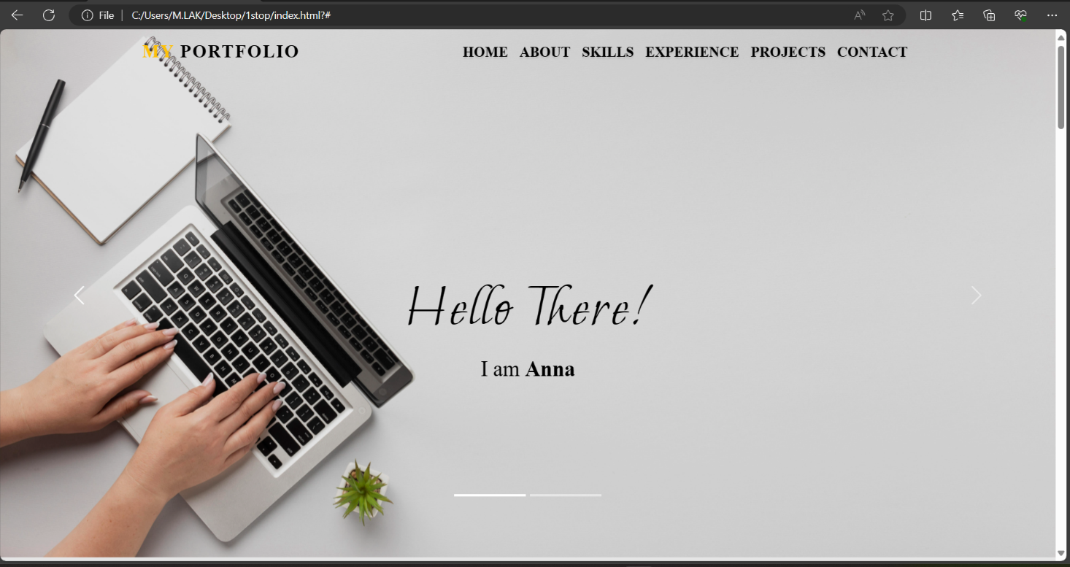

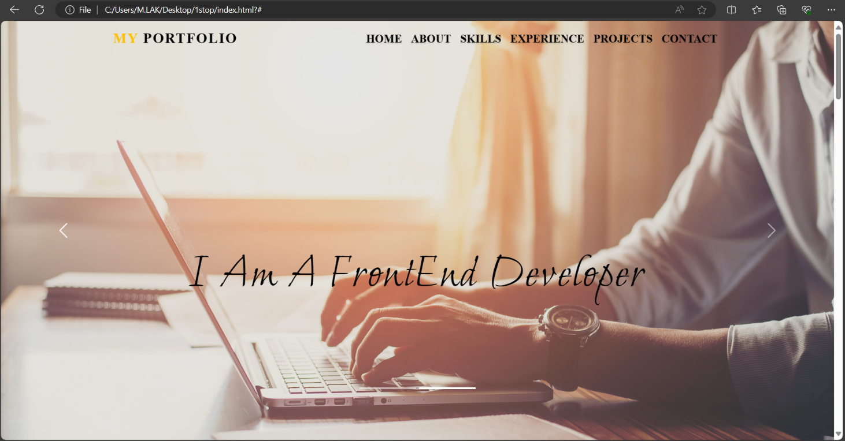

**About page:**

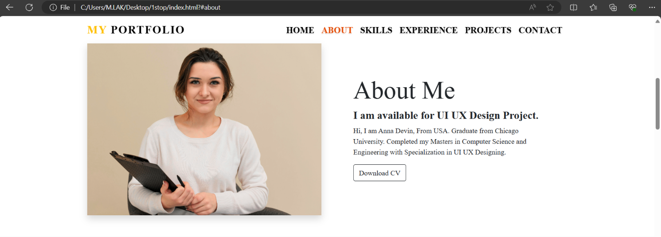

**Skills page:**

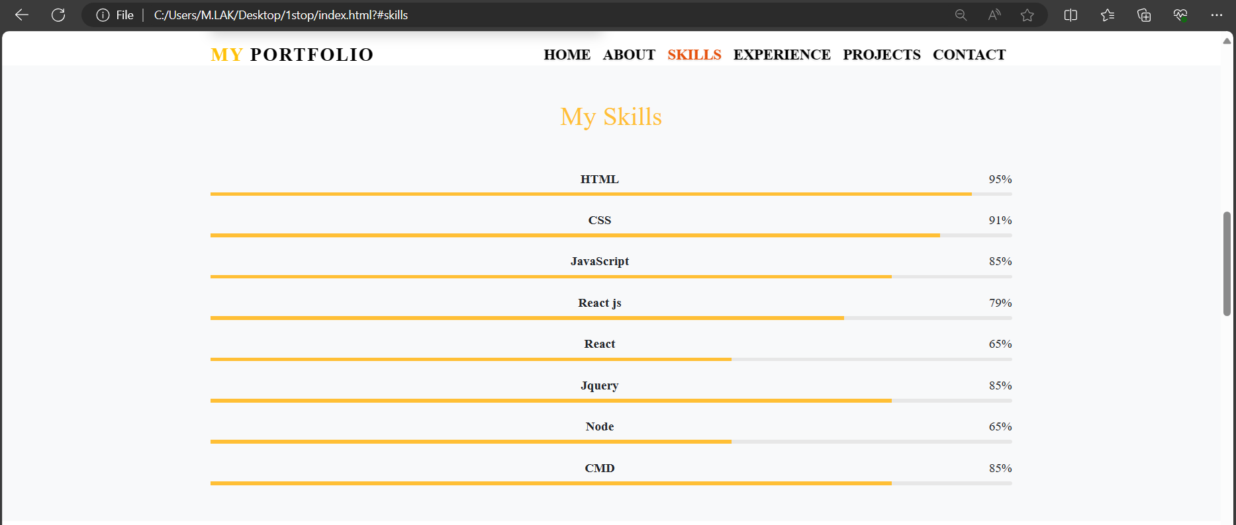

**Experience page:**

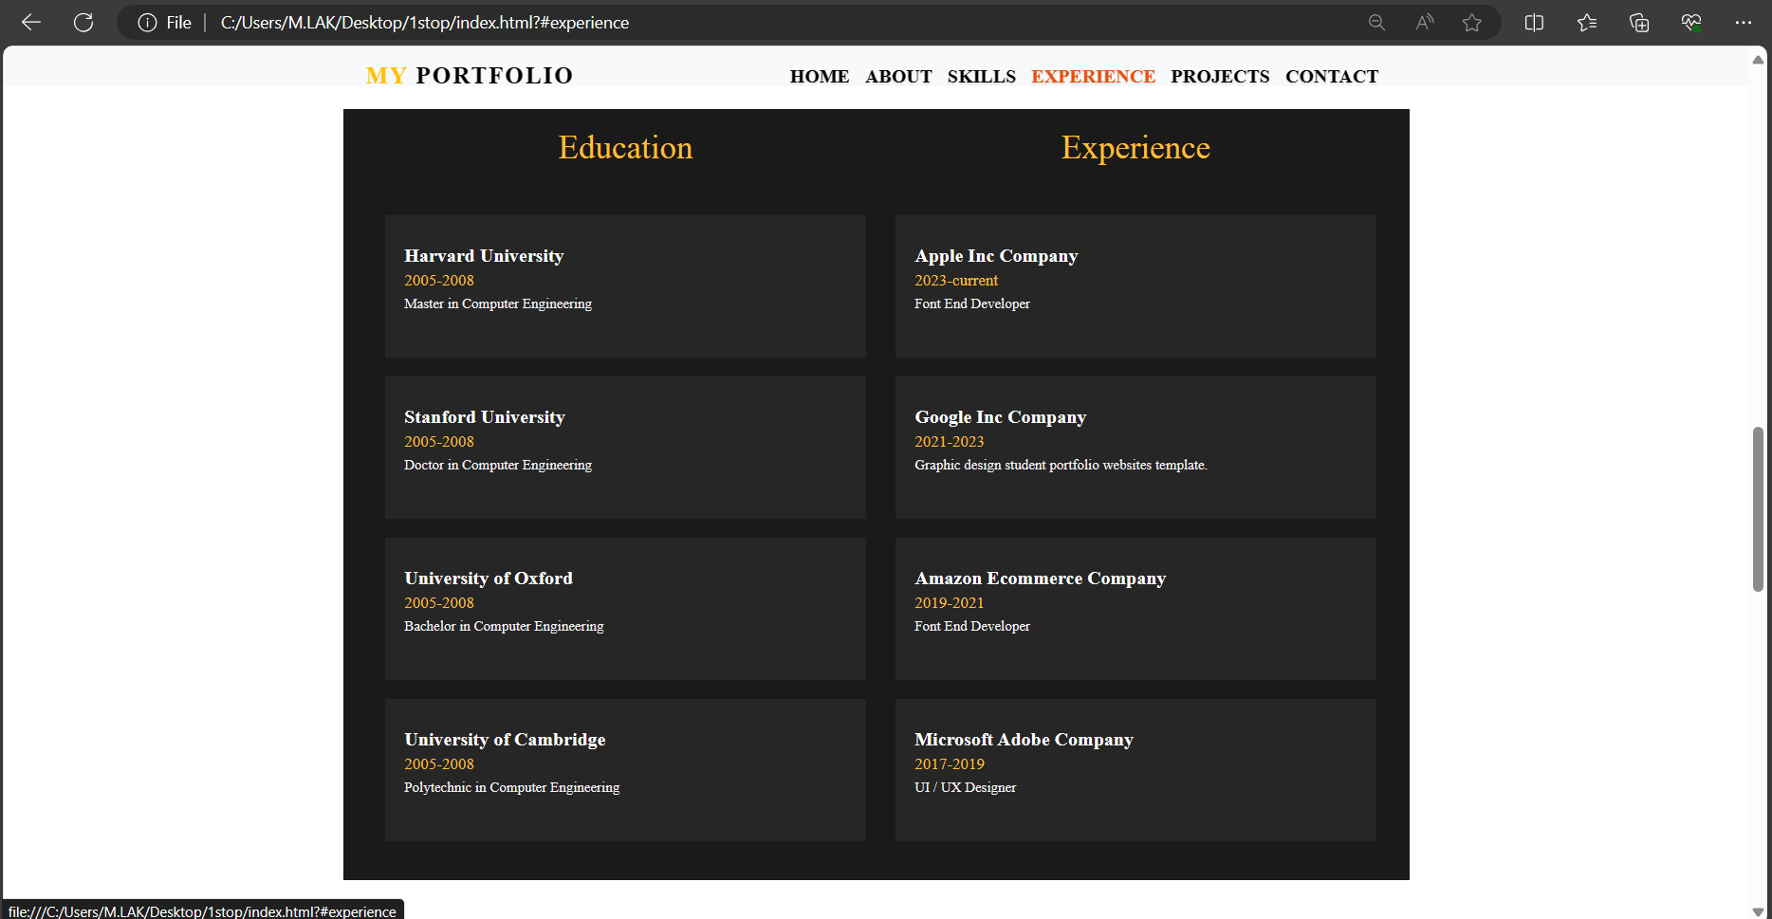

**Projects page:**

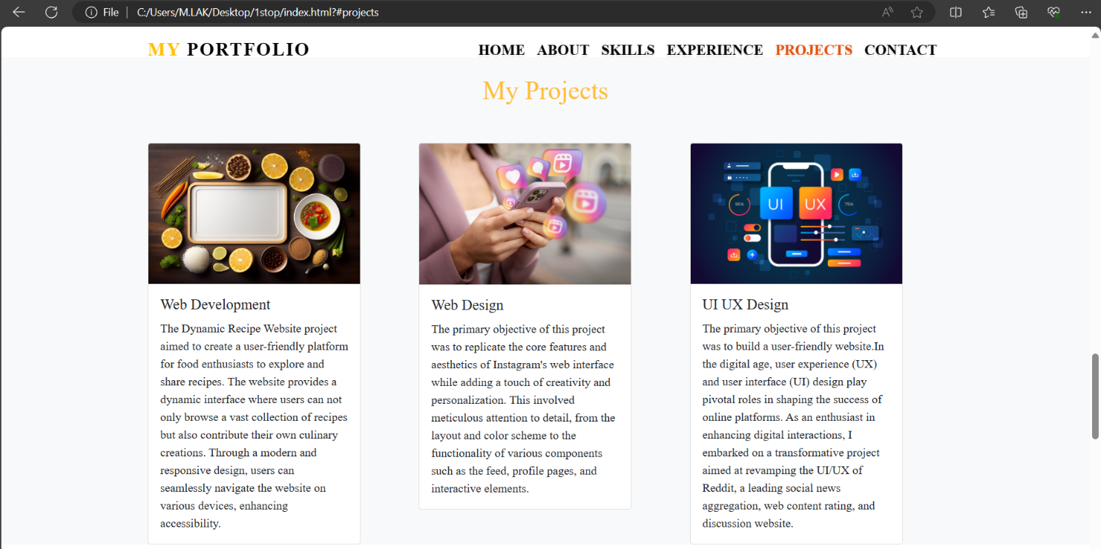

**Contact page:**

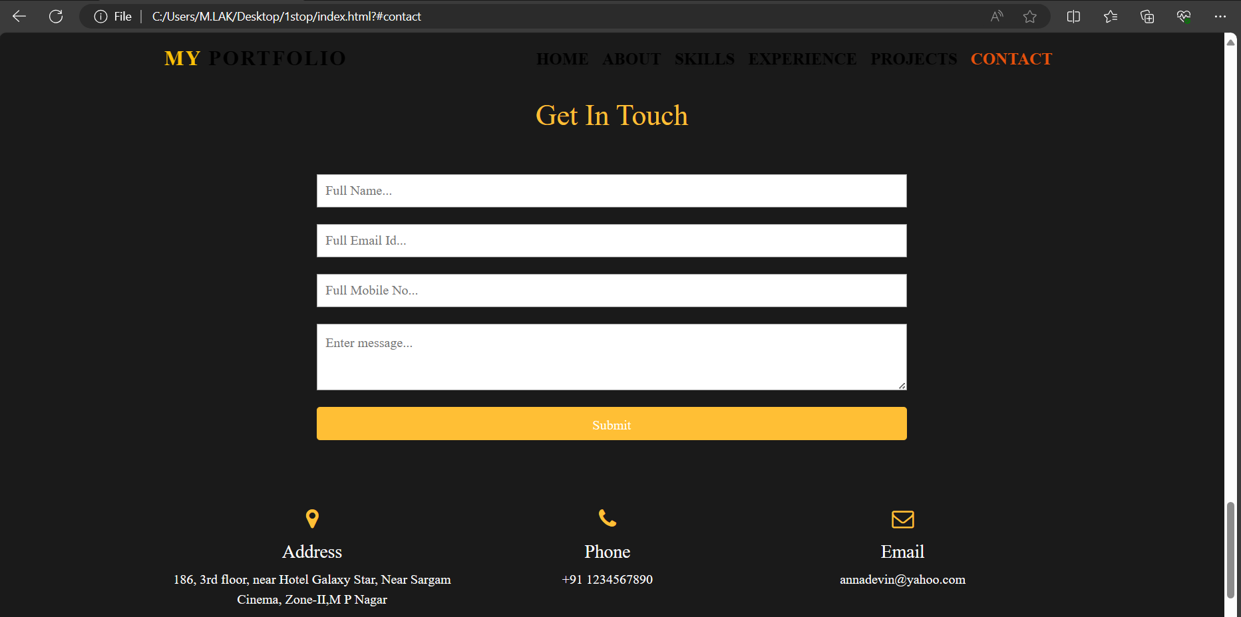

**Footer page:**



**Full website image:**

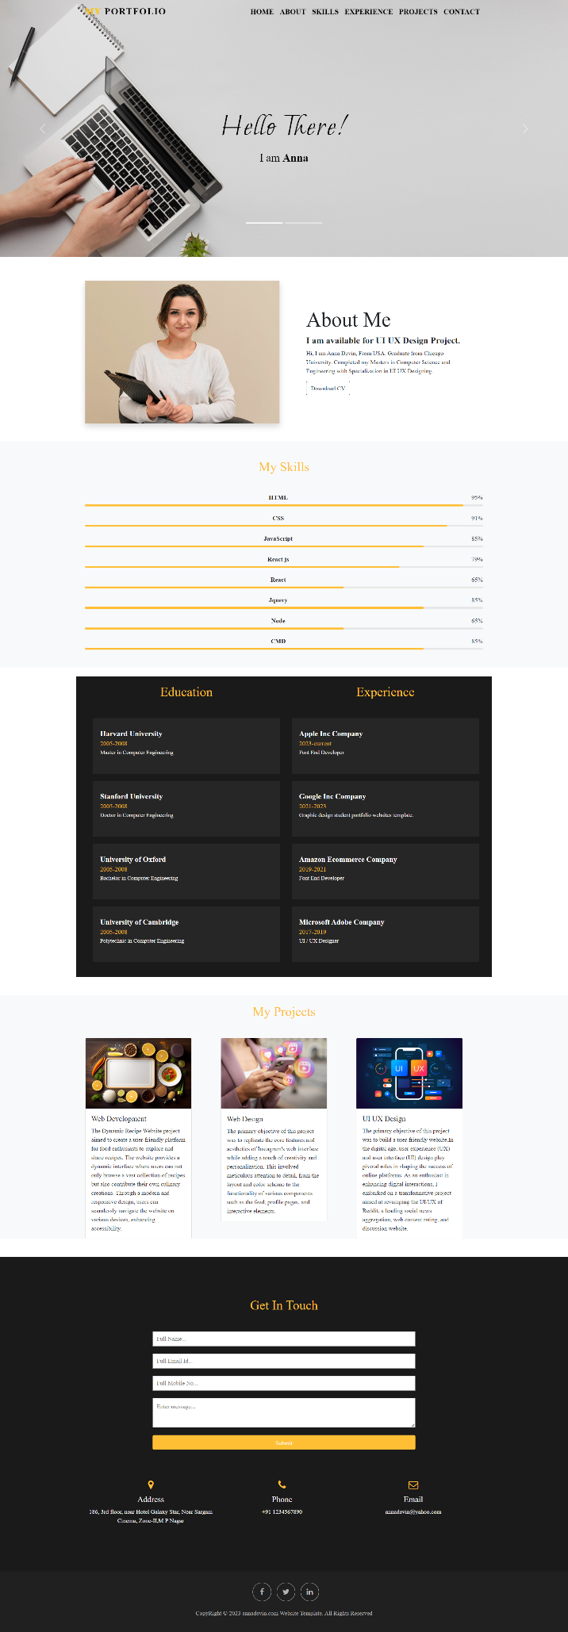

**CONCLUSION**

In conclusion, the creation of a single-page portfolio website using HTML, CSS, JavaScript, and Bootstrap 5 offers a powerful platform for showcasing one's skills, projects, and achievements in a concise and visually appealing manner. This methodology combines the flexibility of HTML and CSS with the interactivity of JavaScript and the responsive design capabilities of Bootstrap 5 to deliver a seamless and engaging user experience.

HTML provides the structural foundation of the website, defining the layout and organizing content into sections such as the header, navigation bar, main content area, and footer. CSS is used to style and customize the appearance of the website, ensuring consistency and visual appeal across different devices and screen sizes.

The integration of JavaScript enhances user interactivity, allowing for features such as smooth scrolling navigation between sections, interactive elements, and form validation. These dynamic elements elevate the user experience, making the website more engaging and user-friendly.

Bootstrap 5 serves as a valuable tool for creating responsive and mobile-first designs, with its grid system, utility classes, and components facilitating the development process. By leveraging Bootstrap's built-in functionality, developers can ensure that the portfolio website is optimized for viewing on a wide range of devices, from desktop computers to smartphones and tablets.

Overall, the creation of a single-page portfolio website represents a balance between design aesthetics, functionality, and usability. By following a structured methodology and leveraging the capabilities of HTML, CSS, JavaScript, and Bootstrap 5, developers can create a professional and visually stunning online portfolio that effectively showcases their skills and accomplishments to potential clients, employers, or collaborators. Whether it's a freelance designer, developer, or artist, a single-page portfolio website offers a versatile and impactful platform for presenting one's work and making a lasting impression in the digital realm.